# 이클립스(STS) + Github + main branch 이용방법

Git > Configuration > init > defaultBranch > main (Github)

1. Github에서 리파지토리 생성

spring-boot-github-exam

2. 이클립스에서 프로젝트 생성 후 작업

spring-boot-github-exam 프로젝트 생성

3. Share Project

[v] Use or create repository…

[Create Repository]

[Finish]

~~Switch to New Branch : main~~

4. commit

git init

git config --global core.autocrlf input

git add README.md # 필요한 파일만. git add src/* git add .project

git commit -m "first commit"

git branch -M main

git remote add origin https://github.com/hpalman/spring-boot-exam.git

git push -u origin main

이클립스 프로젝트 close and open

끝

# 이클립스(STS) + Github + Git for Windows 이용방법

별로 좋은 방법이 아니네!

1. 이클립스에서 프로젝트 생성 후 작업

2. Github에서 리파지토리 생성

3. 이클립스 프로젝트 프로젝트 폴더에서 Git bash 작업(Open Git Bash Here)



git init

git config --global core.autocrlf input

git add README.md # 필요한 파일만. git add src/* git add .project

git commit -m "first commit"

git branch -M main

git remote add origin https://github.com/hpalman/spring-boot-exam.git

git push -u origin main

이클립스 프로젝트 close and open

끝

# github와 sts의 연동

## github에서 repository 생성

github에서 repository spring-boot-exam 생성

## 생성 정보

https://github.com/hpalman/spring-boot-exam.git

### …or create a new repository on the command line

echo "# spring-boot-exam" >> README.md

git init

git add README.md

git commit -m "first commit"

git branch -M main

git remote add origin https://github.com/hpalman/spring-boot-exam.git

git push -u origin main

### …or push an existing repository from the command line

git remote add origin https://github.com/hpalman/spring-boot-exam.git

git branch -M main

git push -u origin main

# sts 작업

## spring-boot-exam 프로젝트 생성

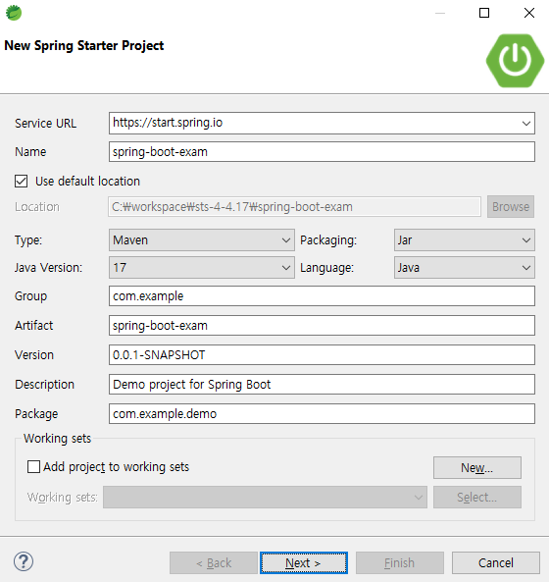

## Share Project

프로젝트 > Team > Share Project…

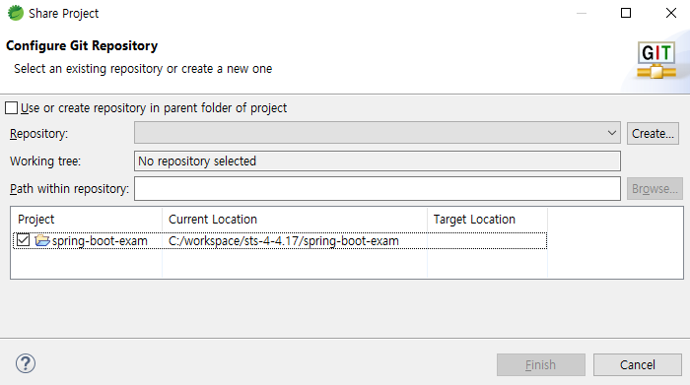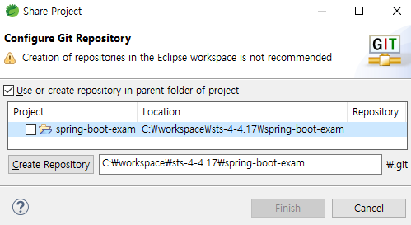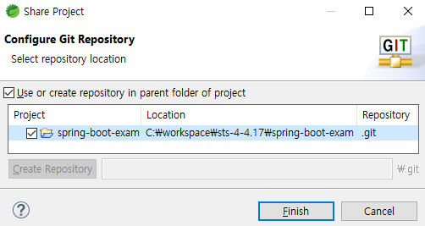

① 체크

[v] Use or create repository in parent folder or project

② 선택

③ 버튼 클릭

④ Finish

## Commit

Project > Team > Commit

## Push

Project > Team > Push Branch `master`

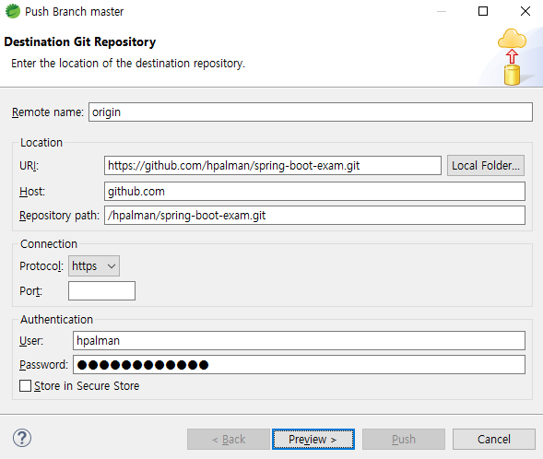

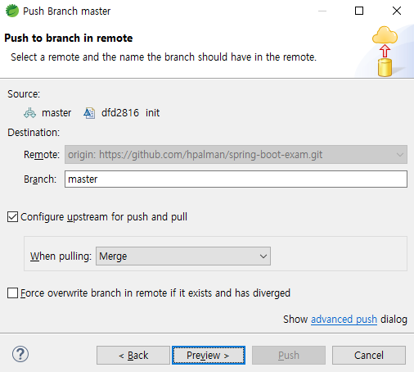

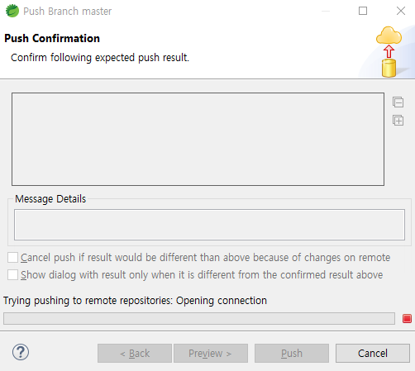

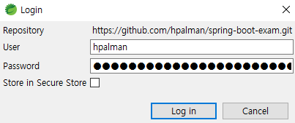

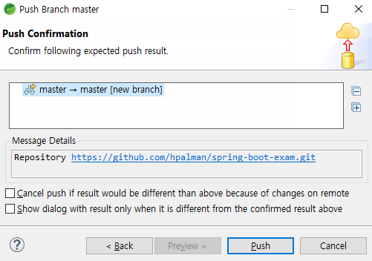



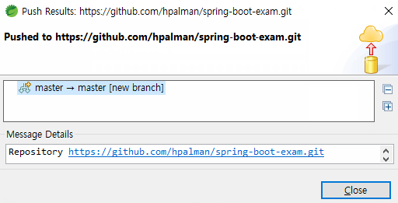

## Github에서 확인

https://github.com/hpalman/spring-boot-exam

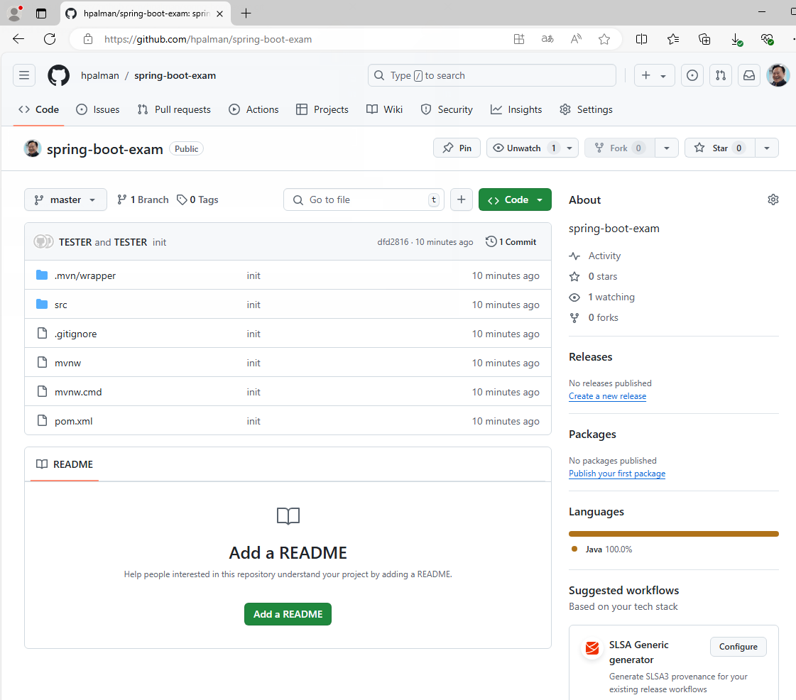

# 끝

# Clone & Commit & Push - STS

### Git Perspective

### Clone a Git repository

(https://github.com/hpalman/spring-boot-exam.git)

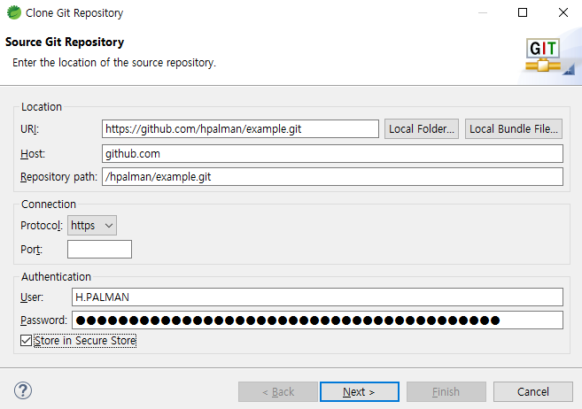

github의 Name(아이디가 아님)

github의 Personal access token

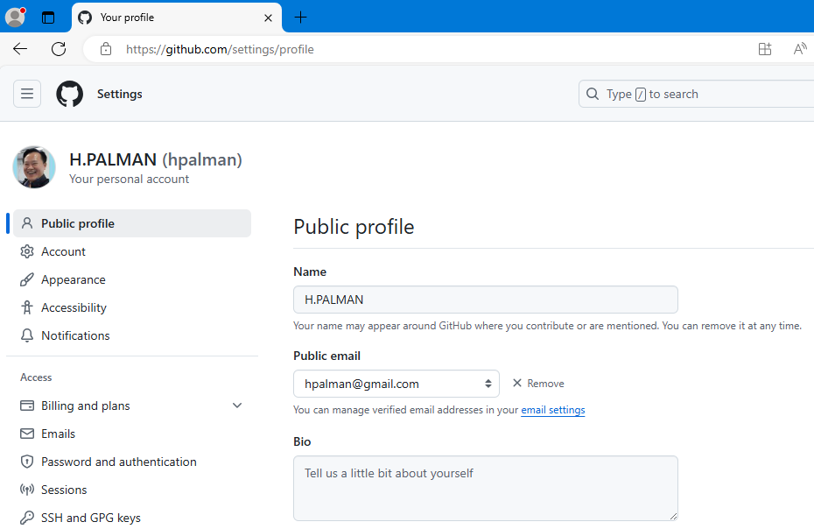

github의 Name

[v] Store in Secure Store

hpalman / hMonDang@!12

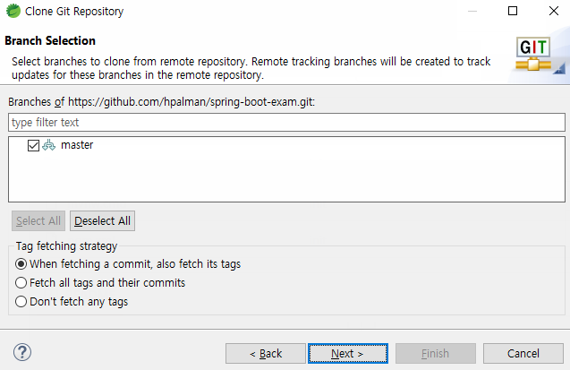

## Import projects

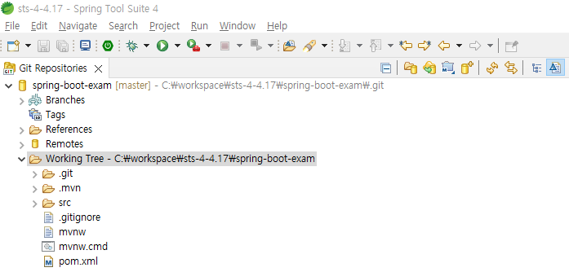

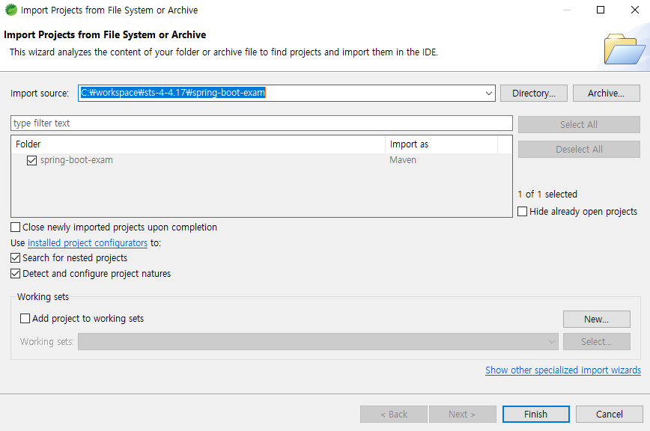

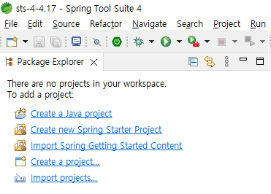

General > Existing Projects into Workspace

C:\workspace\sts-4-4.17\spring-boot-exam

Creation of repositories in the Eclipse workspace is not recommended

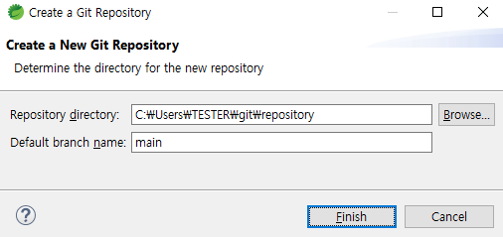

Creation of repositories in the Eclipse workspace is not recommended

Default branch name of Github

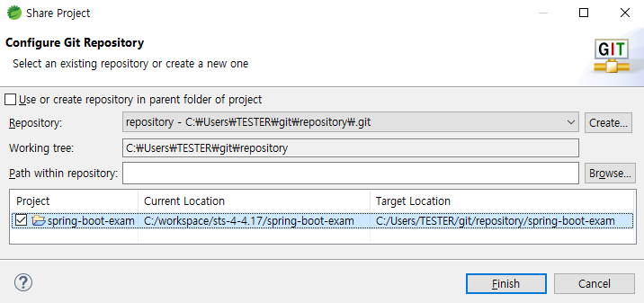

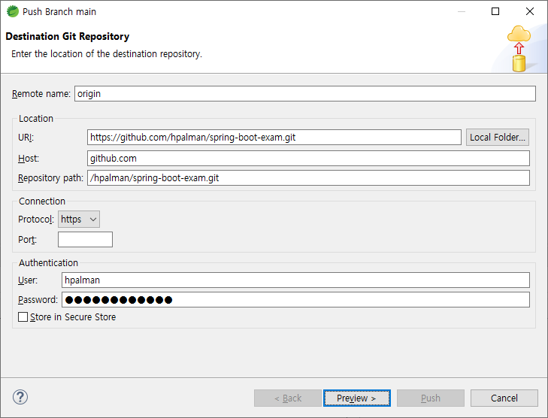

문제점

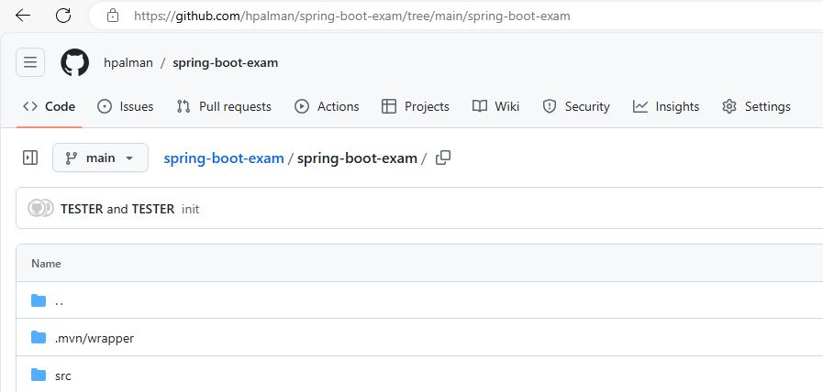

# Clone & Commit & Push - Git for Windows

$ echo "# example" >> README.md

$ git init

$ git commit -m "first commit"

$ git branch -M main

$ git config --global user.email "hpalman@gmail.com"

$ git config --global user.name "H.PALMAN"

$ git remote add origin https://github.com/hpalman/example.git

$ git push -u origin main

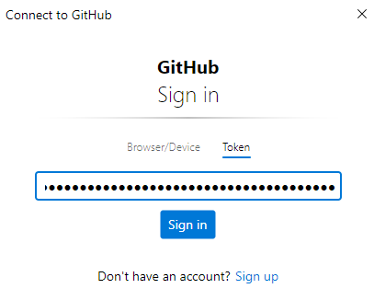

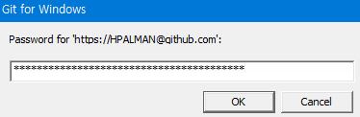

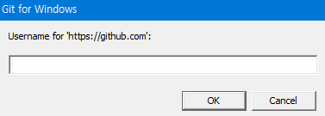

Enumerating objects: 3, done.

Counting objects: 100% (3/3), done.

Writing objects: 100% (3/3), 223 bytes | 223.00 KiB/s, done.

Total 3 (delta 0), reused 0 (delta 0), pack-reused 0 (from 0)

To https://github.com/hpalman/example.git

* [new branch] main -> main

branch 'main' set up to track 'origin/main'.

# Repository 삭제하기

## spring-boot-exam 리파지토리 삭제

### settings

https://github.com/hpalman/spring-boot-exam/settings

또는

https://github.com/hpalman/spring-boot-exam 에서 settings 클릭

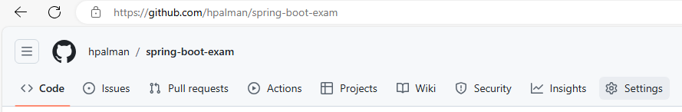

### Delete this repository

Danger Zone > Delete this repository

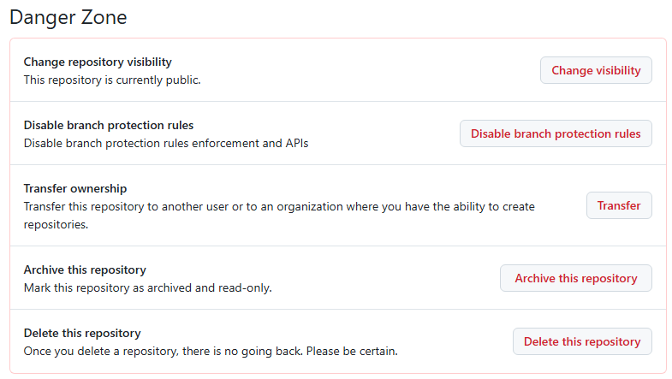

# github와 sts 연동(스크린샷)

## spring-boot-web : 스크린샷

### Create a new repository

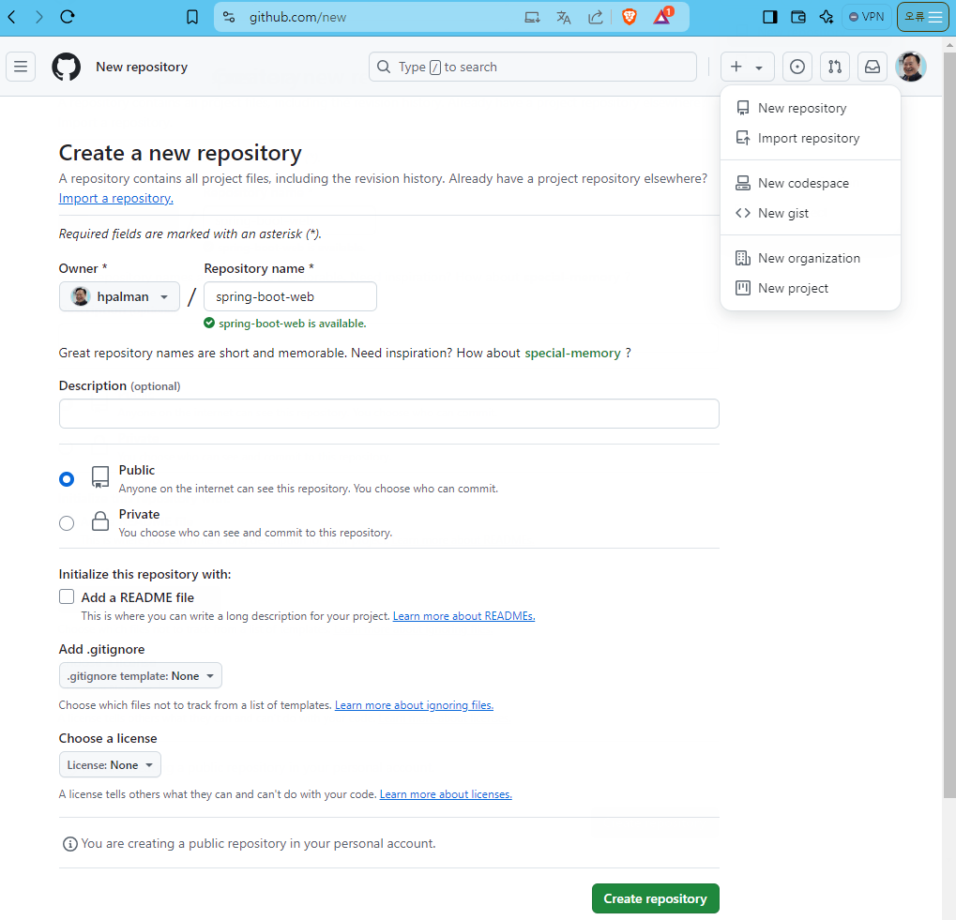

spring-boot-web for sts4

### spring-boot-web 생성결과

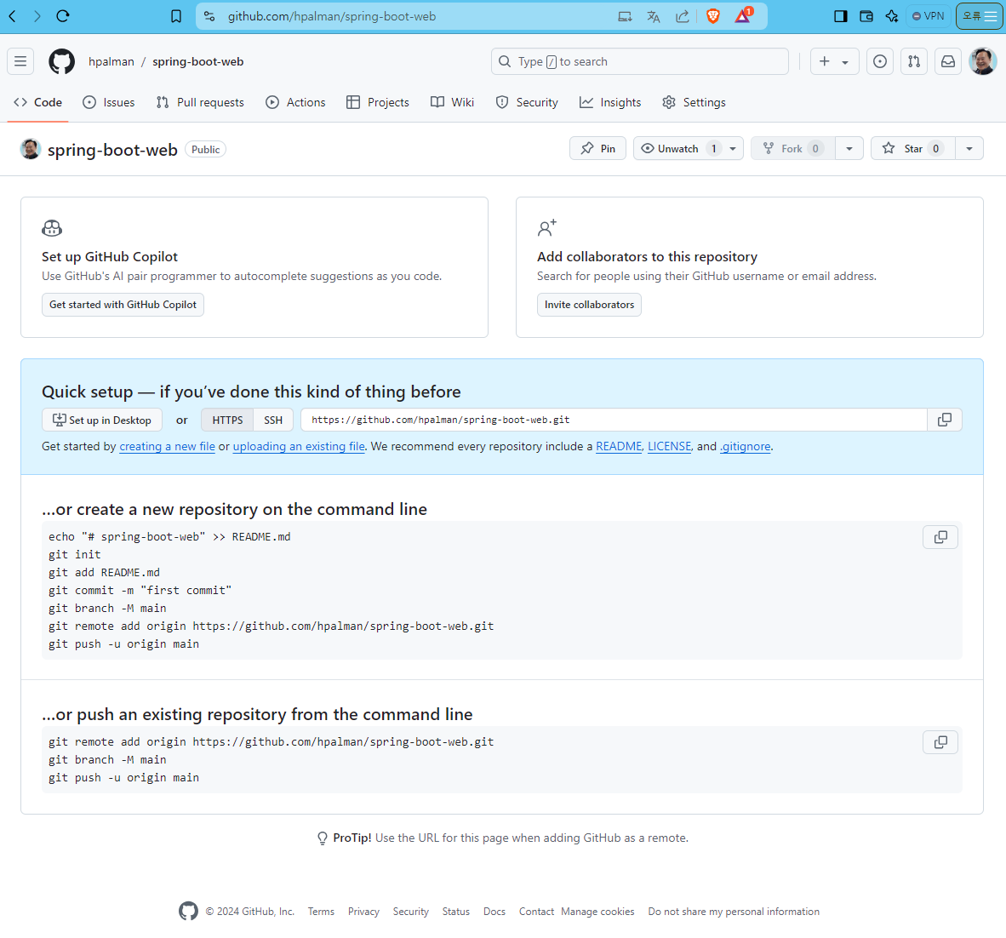

## sts 작업(스크린샷)

### Create new Spring Starter Project

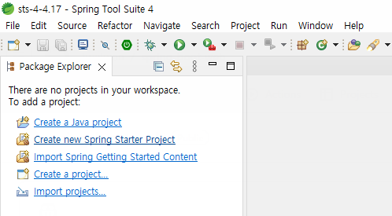

### New Spring Starter Project

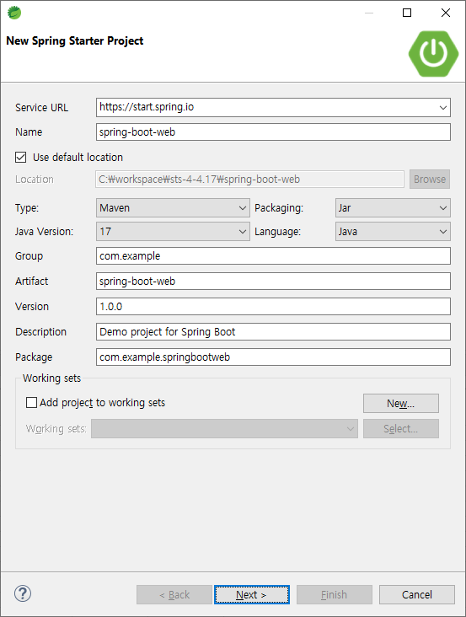

### New Spring Starter Project Dependencies

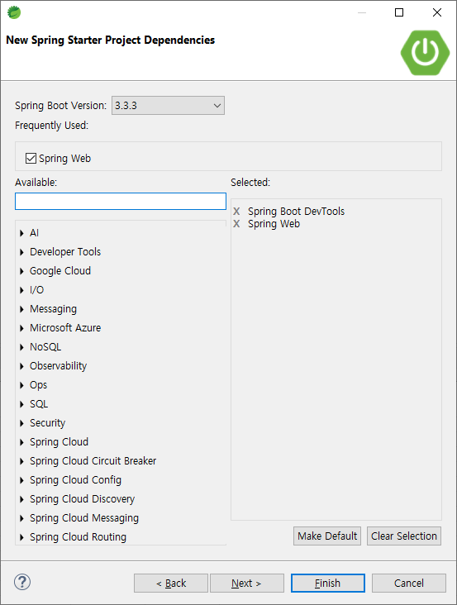

New Spring Starter Project

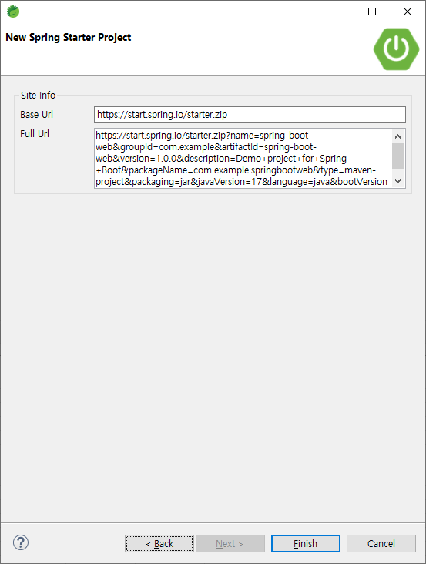

Share Project

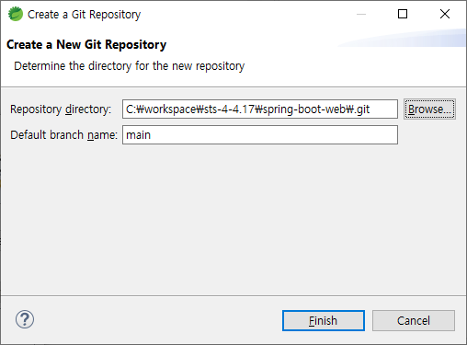

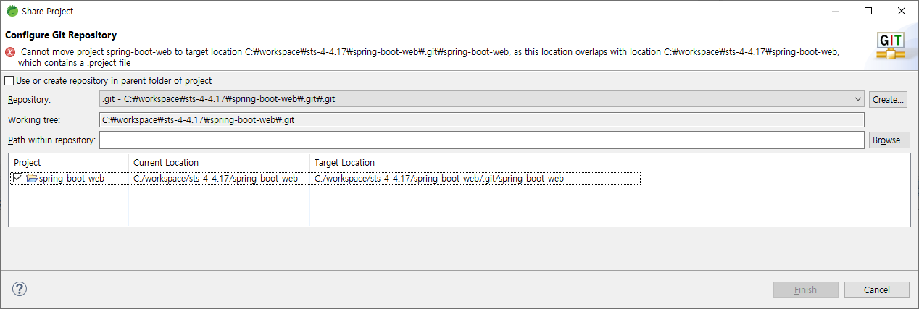

Cannot move project spring-boot-web to target location C:\workspace\sts-4-4.17\spring-boot-web\spring-boot-web, as this location overlaps with location C:\workspace\sts-4-4.17\spring-boot-web, which contains a .project file

